**Data**

1. 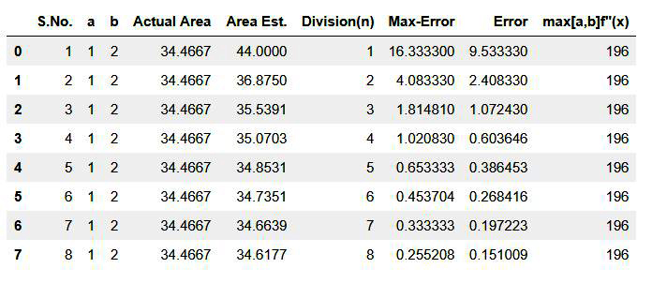Trapezoidal Rule (Q1)

Polynomial Equation: **4x4+2x2+5 [a: lower limit , b: upper limit ]**

1. Trapezoidal Rule (Q2)

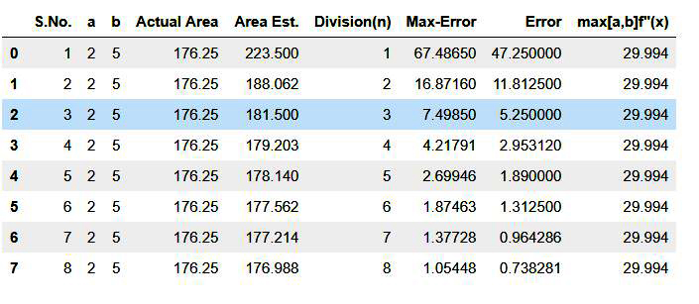Polynomial Equation: **x3+2x+1**

1. Simpson’s Rule (Q1)

Polynomial Equation: **4x4+2x2+5**

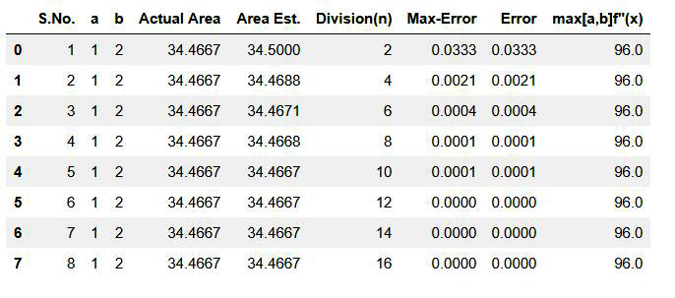

1. Simpson’s Rule (Q2)

Polynomial Equation: **x3+2x+1**

